A STUDENT’S INDUSTRIAL WORK EXPERIENCE SCHEME (SIWES)

HELD AT
Veterinary clinic,
gombi, adamawa state

FROM: AUGUST, 2025
TO: DECEMBER, 2025

BY
MAGAJI MUKTAR
(SA/AHP/ND/24/019)

A SIWES REPORT SUBMITTED TO THE DEPARTMENT OF ANIMAL HEALTH AND PRODUCTION, SCHOOL OF AGRICULTURAL TECHNOLOGY, FEDERAL POLYTECHNIC, MUBI, ADAMAWA STATE, NIGERIA

FEBRUARY, 2026
A STUDENT’S INDUSTRIAL WORK EXPERIENCE SCHEME (SIWES)

HELD AT
Veterinary clinic,
gombi, adamawa state

FROM: AUGUST, 2025
TO: DECEMBER, 2025

BY
MAGAJI MUKTAR
(SA/AHP/ND/24/019)

TITLE PAGE

A SIWES REPORT SUBMITTED TO THE DEPARTMENT OF ANIMAL HEALTH AND PRODUCTION, SCHOOL OF AGRICULTURAL TECHNOLOGY, FEDERAL POLYTECHNIC, MUBI, ADAMAWA STATE, NIGERIA

IN PARTIAL FUFILMENT OF THE REQUIREMENTS FOR THE AWARD OF NATIONAL DIPLOMA (ND) IN ANIMAL HEALTH AND PRODUCTION, TECHNOLOGY

FEBRUARY, 2026

ATTESTATION
I Magaji Muktar here by attest that I did my Industrial attachment program at Veterinary Clinic Gombi, Adamawa State between August, 2025 to December, 2025, and this report is prepared by me and submitted to the siwes coordinator as required. I understand that all information contained in this report are correct and will be penalized if found to be false. I also know that the siwes coordinator may request for additional evidence as requested for reconciliation.

……………………………………. …..……………………..
MAGAJI MUKTAR DATE
(SA/AHP/ND/24/019)

CERTIFICATION
This is to certify that Magaji Muktar with a registration number SA/AHP/ND/24/019 has undergone his student industrial training at Primary Veterinary Clinic Gombi, Adamawa State. In partial fulfilment of the requirements for the award of National Diploma (ND) in Animal Health Production, Federal Polytechnic Mubi as certified by the undersign officer.

………………………………….. ……………………………
MRS. RUFKATU BITRUS KAMBU Date
DEPERTMENTAL SIWES COORDINATOR

DEDICATOIN
This report is dedicated to God almighty for this wisdom and strength and my lovely parents for their love and care throughout the period of my siwes training.

ACKNOWLEDGEMENT
I thank God Almighty for making me to undergo students industrial work experience scheme (SIWES) successfully.
My gratitude goes to my lovely parents for their prayers, financial and moral support during my attachment.
I also appreciate the kind gesture of my brothers and sisters and those who supports me in prayers and contribution during my industrial attachment.
I whole heartedly thank my Head of Department, SIWES coordinator and all lecturers of Animal Health Production Department for their effort to ensure my success as their students.
I am greatly indebted to my co-SIWES students to mention, may God strengthen our relationship together and grant us academic excellence.
I sincerely thank you all for your contribution and support.

TABLE OF CONTENTS

TITLE PAGE i
ATTESTATION ii
CERTIFICATION iii
DEDICATOIN iv
ACKNOWLEDGEMENT v
TABLE OF CONTENTS vi
CHAPTER ONE 1
INTRODUCTION 1
1.1 Brief History of SIWES 1
1.2 Objective of SIWES 2
1.3 Significance of SIWES 2
CHAPTER TWO 3
ORGANIZATIONAL PROFILE 3
2.1 Overview of the Organization 3
2.3 Organizational Chart 3
CHAPTER THREE 4
WORK EXPERIENCE 4
3.1 CASTRATION 4
3.2 HOW TO TREAT HELMINTHES 6
3.3 FILING ANIMAL NAILS 7
3.4 DETECTION TREATMENT OF THICKS 9
3.5 VACCINATION OF ANIMALS (CBPP) 10
CHAPTER FOUR 11
SUMMARY, CONCLUSION, AND RECOMMENDATIONS 11
4.1 Summary 11
4.2 Conclusion 11
4.3 Recommendations 12
REFERENCES 13

CHAPTER ONE

INTRODUCTION

1.1 Brief History of SIWES
The Students’ Industrial Work Experience Scheme (SIWES) was established in 1973 by the Industrial Training Fund (ITF) to address the gap between theoretical knowledge and practical skills among Nigerian tertiary institution graduates (ITF, 2010). Prior to its establishment, there was a growing concern among industrialists regarding the lack of practical experience among graduates, especially those in science and technology disciplines (Akinyemi, 2011). The SIWES program serves as a skills development initiative aimed at preparing students from universities, polytechnics, and colleges of education for real-world industrial environments.
This initiative was designed to enhance students’ ability to apply their classroom knowledge to real-life situations, facilitate their transition to the workplace, and equip them with the necessary technical and operational skills. It provides students the opportunity to operate and interact with equipment and machines not commonly found in their schools (Oladele & Akintayo, 2013).
Before SIWES, employers found that graduates lacked job-ready competencies due to a lack of exposure to the practical side of their disciplines. This led to high unemployment and dissatisfaction with the quality of graduates being produced (Adegboye, 2012). The situation prompted the ITF to introduce the SIWES scheme in 1973/74 as a solution to the disconnect between classroom learning and workplace demands.
Initially fully funded by the ITF, the financial burden led to the fund’s withdrawal in 1978. Consequently, the federal government transferred the scheme’s coordination to the National Universities Commission (NUC) and the National Board for Technical Education (NBTE) in 1979. Later in 1984, the supervision and implementation of SIWES were handed back to the ITF, which resumed full management of the program in July 1985 with federal government funding (ITF, 2010).

1.2 Objective of SIWES
- To provide an avenue for student in the Nigerian Institution to acquire industrial skills and experience during their course of study.
- To prepare students for the work situation they are likely to meet after graduation.
- To expose the student to work method and techniques in handling equipment and machinery that may not be available in their institution.
- To allow the transition phase from school to the world of working environment easier and facilitate students contact for later job placements.
- To provide student with an opportunity to apply their theoretical knowledge in real work situation thereby bridging the gap between theory and practice.

1.3 Significance of SIWES
In the earlier stage, students are graduating without any technical knowledge or working experience and this makes them to undergo further training after securing an employment. With this reason, student industrial training was established. During this program, as designed by the ITF, students are expected to get technical assistance and acquire more experience scheme in their chosen field of study and exposed them to the usage of source machines and safety precaution where relevant before the completion of their program in their various institutions.

CHAPTER TWO

ORGANIZATIONAL PROFILE

2.1 Overview of the Organization
The Veterinary Clinic in Gombi, Adamawa State, is part of a renewed push by the state government to strengthen livestock health infrastructure. As of late 2023 and early 2024, the Adamawa State Government, under Governor Ahmadu Umaru Fintiri, has prioritized the construction and upgrading of veterinary facilities, including a commissioned veterinary diagnostic centre in Gombi.
The Gombi center is part of a broader, state-wide initiative designed to improve animal disease surveillance and vaccination, often in partnership with the World Bank-assisted Livestock Productivity and Resilience Support (L-PRES) project. The Gombi facility is aimed at supporting local farmers and pastoralists by offering improved diagnostic services, reducing the burden of disease, and enhancing livestock productivity in the area. Gombi is identified as one of the key locations for these interventions, along with other areas like Mubi and Yola, designed to improve the economic capacity of cattle markets and overall agricultural health in the state.

2.3 Organizational Chart
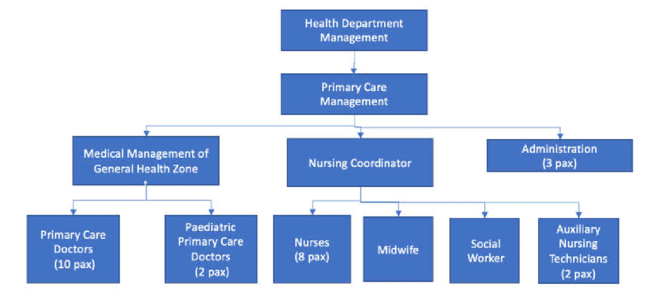
Figure 2.1: Organizational Chart

CHAPTER THREE

WORK EXPERIENCE

3.1 CASTRATION
Castration of goat was one of the livestock management practices I observed and participated in during my SIWES training under the supervision of trained livestock personnel. The exercise was carried out to control breeding, reduce aggressive behavior in male goats, and improve meat quality. Castration involved the removal or inactivation of the testes, which prevented reproduction and reduced the level of male hormones such as testosterone.
Steps Involved in Castration of Goat
- The goat was carefully examined to ensure it was healthy and suitable for castration.
- The animal was properly restrained to prevent injury and reduce stress during the procedure.
- The scrotal area was thoroughly cleaned and disinfected using an antiseptic solution.
- Sterilized instruments such as a blade, scalpel, or elastrator were prepared for use.
- A small incision was made at the lower end of the scrotum using a sterilized blade.
- The testes were gently exposed and removed.
- Bleeding was controlled, and antiseptic was applied to the wound.
- The goat was observed for signs of bleeding, swelling, or infection.
- The animal was kept in a clean environment and monitored until proper healing occurred.
Drugs Administered
- Penicilin (procaine)
- Multi-vitamine
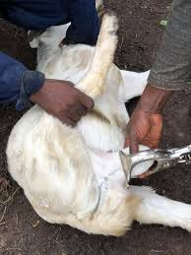
Figure 3.1: Castration of Goat

3.2 HOW TO TREAT HELMINTHES
Treatment of helminth infestation was one of the routine animal health management practices I observed and participated in during my SIWES training. Helminths are parasitic worms that infect livestock and negatively affect their health, growth, and productivity. Common helminths encountered included roundworms, tapeworms, and flukes.
Steps in the Treatment of Helminths
- The animals were observed and examined for signs of helminth infestation such as weight loss, diarrhea, weakness, rough hair coat, and poor appetite.
- Suspected animals were isolated or properly identified for treatment.
- The body weight of each animal was estimated or measured to determine the correct drug dosage.
- Appropriate anthelmintic drugs were selected based on the type of parasite suspected.
- The required dosage of the drug was carefully calculated according to standard veterinary guidelines.
- The animals were properly restrained to ensure safe and accurate drug administration.
- The anthelmintic drugs were administered either orally or through injection using clean and sterilized equipment.
- Proper hygiene and sanitation were maintained throughout the treatment process.
- The animals were monitored after treatment for improvement and possible adverse reactions.
- Preventive measures such as regular deworming, proper sanitation, and good feeding practices were implemented to prevent reinfestation.
Drugs Administered
- Albandazole
- Livermisole

3.3 FILING ANIMAL NAILS
Filing of animal nails was one of the routine animal care activities I carried out during my SIWES training under the supervision of experienced livestock attendants. This practice was done to maintain proper hoof and nail length, prevent injuries, improve animal comfort, and reduce the risk of infections and lameness.
Steps in Filing Animal Nails
- The animal was carefully examined to assess the condition and length of the nails.
- The animal was properly restrained to prevent sudden movement and ensure safety.
- Appropriate tools such as nail cutters, hoof files, or rasps were selected and disinfected.
- Excess nail length was gently trimmed using a nail cutter where necessary.
- A hoof file or rasp was used to file the nails smoothly to the correct shape and length.
- Care was taken to avoid filing too deep to prevent pain or bleeding.
- The nails were inspected for cracks, injuries, or infections after filing.
- Antiseptic was applied if minor cuts were observed.
- The animal was released and observed to ensure normal movement and comfort.
- Tools were cleaned and stored properly after the procedure.

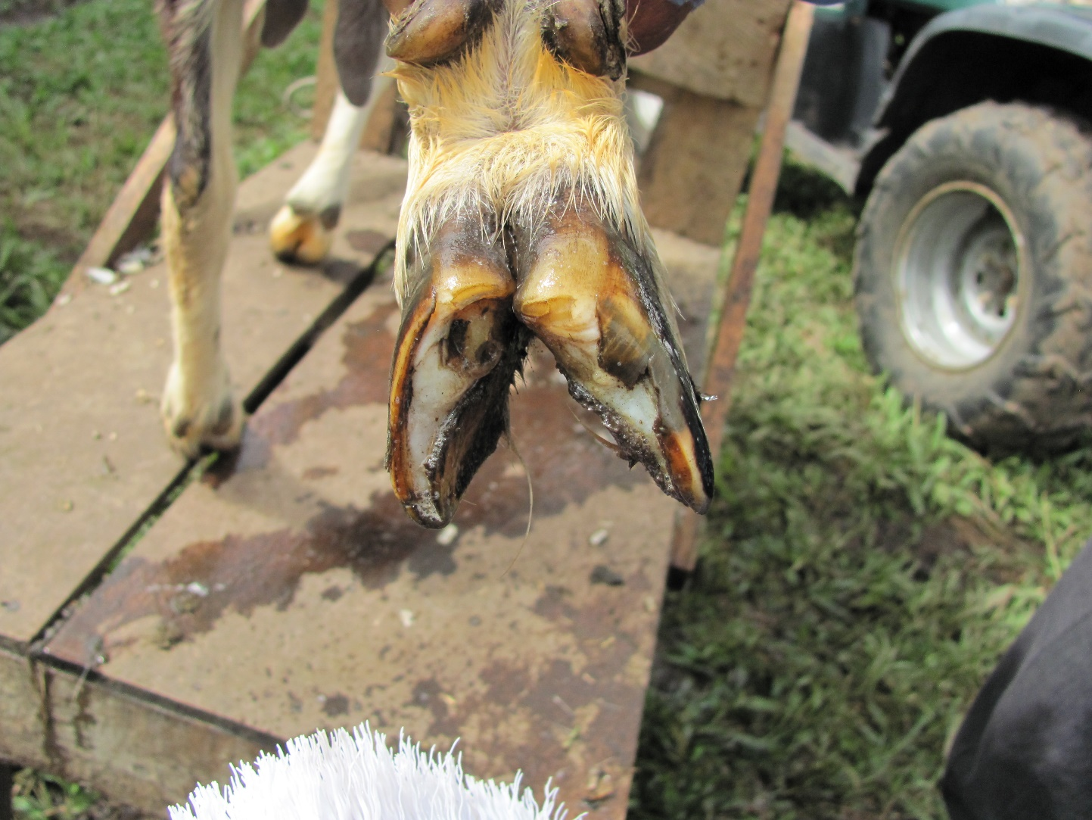
Figure 3.2: Filing of Animal nails

3.4 DETECTION TREATMENT OF THICKS
Animals were carefully examined through physical inspection. Common areas checked included the ears, neck, under the tail, groin, between the legs, and around the udder or scrotum. Ticks were identified as small, dark, or swollen parasites firmly attached to the skin. Signs such as restlessness, scratching, hair loss, wounds, and anemia were also used to suspect tick infestation. Once infestation was detected, appropriate control measures were applied. The animals were properly restrained before treatment. Tick control chemicals known as acaricides were prepared according to recommended concentrations. Common methods of treatment included spraying, dipping, or topical application of acaricides.
Steps in Detection and Treatment of Ticks
- The animals were properly restrained to allow thorough examination.
- The body of each animal was carefully inspected, paying attention to common tick sites such as the ears, neck, groin, under the tail, and between the legs.
- Ticks were identified as small or swollen parasites attached firmly to the skin.
- Signs such as scratching, wounds, hair loss, and restlessness were noted to confirm infestation.
- Visible ticks were carefully removed using forceps or gloved hands.
- Antiseptic was applied to the affected areas after tick removal to prevent infection.
- Appropriate acaricides were prepared according to the recommended concentration.
- The acaricides were applied to the animals by spraying, dipping, or topical application.
- The animals were observed after treatment for any adverse reactions.
- Animal housing and surroundings were cleaned to reduce the risk of re-infestation.
Drugs Administered
- Ivermectine

3.5 VACCINATION OF ANIMALS (CBPP)
Vaccination of animals against Contagious Bovine Pleuropneumonia (CBPP) was one of the animal health management activities I observed and participated in during my SIWES training under the supervision of veterinary personnel. CBPP is a highly contagious bacterial disease affecting cattle, characterized by respiratory distress, fever, coughing, nasal discharge, and reduced productivity. Vaccination is an effective preventive measure used to control the spread of the disease.
Before the vaccination exercise, the animals were examined to ensure they were healthy and fit for vaccination. Sick, weak, or stressed animals were excluded from the process. The vaccination materials, including the CBPP vaccine, syringes, needles, and antiseptics, were prepared and handled under proper cold-chain conditions to maintain vaccine potency
Steps in Vaccination of Animals (CBPP)
- The animals were examined to ensure they were healthy and fit for vaccination.
- Sick, weak, or stressed animals were separated and excluded from vaccination.
- The CBPP vaccine was prepared and kept under proper cold-chain conditions.
- Vaccination materials such as syringes, needles, and antiseptics were assembled and disinfected.
- The animals were properly restrained to ensure safety during vaccination.
- The injection site, usually the neck region, was cleaned and disinfected.
- The correct dosage of the CBPP vaccine was drawn into a sterile syringe.
- The vaccine was administered to the animal by subcutaneous injection.
- The vaccinated animals were marked for identification and records were taken.
- The animals were observed after vaccination for any adverse reactions.

CHAPTER FOUR

SUMMARY, CONCLUSION, AND RECOMMENDATIONS

4.1 Summary
This report summarized the practical experiences and knowledge acquired during my Students Industrial Work Experience Scheme (SIWES) training. The training provided me with hands-on exposure to livestock management and animal health practices, which complemented the theoretical knowledge gained in the classroom.
During the training period, I actively participated in various animal husbandry and health management activities such as castration of goats, treatment of helminth infestations, detection and treatment of ticks, and filing of animal nails. These activities enhanced my understanding of proper animal handling techniques, hygiene practices, disease prevention, and routine animal care. The training also exposed me to the importance of teamwork, discipline, time management, and adherence to safety measures in a practical work environment.

4.2 Conclusion
The SIWES training was a valuable and rewarding experience that significantly improved my practical skills and professional competence. It bridged the gap between theoretical knowledge and real-life application by allowing me to participate actively in livestock management and animal health practices.
Through this program, I gained confidence in handling animals, administering treatments, observing hygiene standards, and understanding the importance of preventive healthcare in animal production. The training has prepared me better for future professional challenges and contributed positively to my academic and career development.

4.3 Recommendations
Based on my experiences during the SIWES training, the following recommendations are made:
- Students should be properly oriented before the commencement of SIWES to maximize the benefits of the training.
- Training organizations should provide adequate tools, equipment, and protective materials to ensure effective learning and safety.
- Institutions should strengthen supervision and monitoring of students during SIWES to ensure meaningful participation.
- Students should be encouraged to take the program seriously and actively engage in all assigned duties.
- Government and relevant agencies should improve funding and support for SIWES programs to enhance training quality and student welfare.

REFERENCES
Adegboye, R. O. (2012). Challenges of industrial training in Nigeria. Lagos: Yaba College Press.
Akinyemi, S. (2011). Bridging the skills gap in Nigerian higher institutions: The SIWES approach. Nigerian Journal of Educational Research, 14(3), 22–29.
Industrial Training Fund (ITF). (2010). SIWES Policy Document. Jos: ITF Publications.
Oladele, J. O., & Akintayo, M. O. (2013). Effectiveness of the Students’ Industrial Work Experience Scheme (SIWES) in Nigerian tertiary institutions. Journal of Technical Education and Training, 5(1), 35–42.

